Q1:
The bug is caused by a recursive call to run() method. Each call to this method creates a new thread, thus a new stack space is also added to the entire program stack. When the entire stack is used up, stackoverflow bug occurs.

I fixed this bug by replacing the recursive call with a while loop. Thus no extra stack space is created for run(); there will be only one stack space for run().

Q2:
CopyOnWriteArrayList uses iterator to avoid concurrencyModificationException. Each thread creates a fresh copy of CopyOnWriteArrayList object, thus each thread essentially modifies(add or remove or other operations) a standalone copy. And all modification methods are synchronized so when one thread is modifying the CopyOnWriteArrayList object, other threads must wait for it. After this thread finished its modification and replace the base copy with the modified copy, other threads are then permitted to modify it. This is why it will not throw concurrencyModificationException.

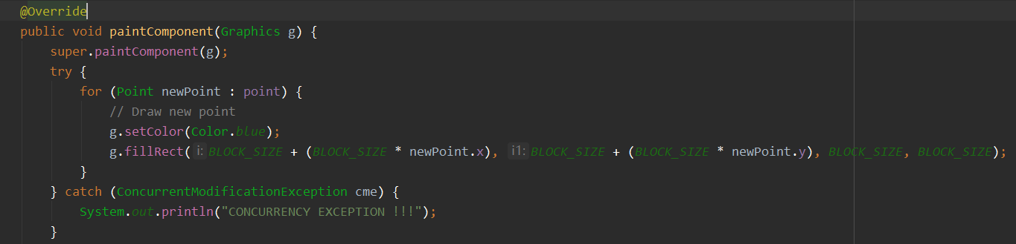

If point were an instance of ArrayList, other threads would cause ConcurrencyModificationException thrown when they modify it. With CopyOnWriteArrayList, the thread calling this method is essentially using its own copy of point. So no exception will be thrown.

Q3:
CopyOnWriteArrayList is costly because it creates a new copy each time a mutative operation is performed.

Q4:
Run 1: 2.526 seconds
Run 2: 2.568 seconds
Run 3: 2.127 seconds
Run 4: 2.630 seconds
Run 5: 2.393 seconds

